Security and the Law

Mobile App Project Guide

(Name Pending)

Contents Page

Preface

Sections/Content

Graphical User Interface(s) (GUIs)

Information/Data

Country List

Pseudocode

References

Preface

The purpose of this app is to provide users with up-to-date information regarding the security and legal climate of every country in the world. This will be achieved by categorising each country via a five criteria rating framework (with sub criteria), which will average into an overarching ranking based on security and legal rights. Users will also be able to receive alerts for selected countries linking them to media and news outlets (via Google News) regarding security and/or law. This app will seek to benefit travellers, businesspeople and those with a related interest in any specific country.

The group whom have compiled this brief will provide rudimentary updates and also advice from the computer science groups regarding the mobile app. The group will also be responsible for providing the necessary information/data.

The information provided and ideas/names given to certain aspects of the project are subject to group input and change, nothing is confirmed until the project is sent to the computer science department.

Sections/Content

List of Countries (plus ‘Search:’ and ‘Menu’ functions)

After a transitory animation upon entering the app, a scroll screen with a search bar at the top, a drop down menu box, and two columns of countries (shown via flag and name) in alphabetical order will appear. Users can select an individual country, enter a country via the search bar, or go to a different list via the menu box.

Country Overall Ranking

This section (available via the menu box) will take the user to a screen where an average score of the five criteria for each country (see below) will be calculated and be provided a ranking accordingly.

Country Criteria Ranking

The following five criteria will be scored for each country (to be determined):

(*Via the World Justice Project Spreadsheet*)

* Government Accountability [*Factor(s) 1 & 3*]
* Absence of Corruption [*Factor 2*]
* Fundamental Rights [*Factor 4*]
* Public Order and Security [*Factor 5*]
* Civil & Criminal Justice [*Factor(s) 7 & 8*]

Each criterion will have a selection option in the menu box and its corresponding screen will display the rankings of each country based on the respective criteria selected.

Media (via Country)

This section (available via the menu box) will take the user to a screen where each country can be linked to news articles relating to security and legal information in the selected country. This will likely be the most ambitious section of the app, but it would greatly increase its benefit for prospective users.

Country List

|  |  |  |
| --- | --- | --- |
| Afghanistan  Albania  Antigua and Barbuda  Argentina  Australia  Austria  Bahamas  Bangladesh  Barbados  Belarus  Belgium  Belize  Bolivia  Bosnia and Herzegovina  Botswana  Brazil  Bulgaria  Burkina Faso  Cambodia  Cameroon  Canada  Chile  China  Colombia  Costa Rica  Cote d’Ivoire  Croatia  Czech Republic  Denmark  Dominica  Dominican Republic  Ecuador  Egypt  El Salvador  Estonia  Ethiopia  Finland  France  Georgia | Germany  Ghana  Greece  Grenada  Guatemala  Guyana  Honduras  Hong Kong  Hungary  India  Indonesia  Iran  Italy  Jamaica  Japan  Jordan  Kazakhstan  Kenya  Kyrgyzstan  Lebanon  Liberia  Macedonia  Madagascar  Malawi  Malaysia  Mexico  Moldova  Mongolia  Morocco  Myanmar  Nepal  Netherlands  New Zealand  Nicaragua  Nigeria  Norway  Pakistan  Panama  Peru | Philippines  Poland  Portugal  Republic of Korea (South Korea)  Romania  Russia  Senegal  Serbia  Sierra Leone  Singapore  Slovenia  South Africa  Spain  Sri Lanka  St. Kitts and Nevis  St. Lucia  St. Vincent and the Grenadines  Suriname  Sweden  Tanzania  Thailand  Trinidad and Tobago  Tunisia  Turkey  Uganda  Ukraine  United Arab Emirates  United Kingdom  United States  Uruguay  Uzbekistan  Venezuela  Vietnam  Zambia  Zimbabwe |

Graphical User Interface(s) (GUIs)

The app will present the world map as an opening screen with the chosen title (to be determined). There is a .zip folder containing each nation’s flag in button form, each country’s flag will be a hyperlink to its respective criteria ranking information.

Example(s):

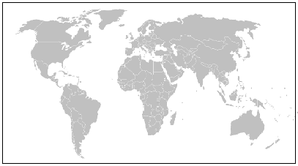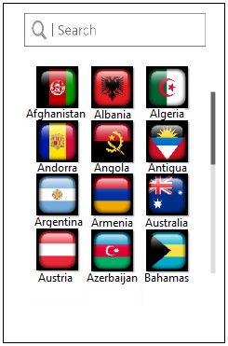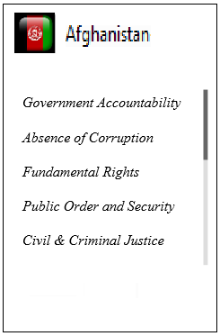Note: The flags shown in the GUI example(s) will be provided to each mobile app development group.

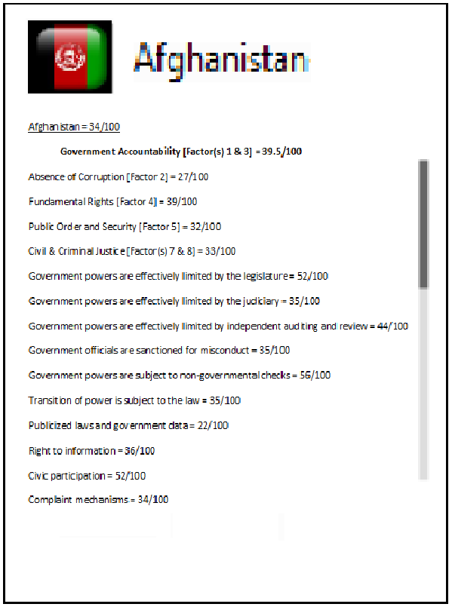

Information/Data

(*To be completed as divided amongst group members*)

(*Information supplied separately*)

Format: (*Each criteria is given a score out of 100 and then an average is calculated*)

Country

**Government Accountability [*Factor(s) 1 & 3*] =**

|  |
| --- |
| Government powers are effectively limited by the legislature = |
| Government powers are effectively limited by the judiciary = |
| Government powers are effectively limited by independent auditing and review = |
| Government officials are sanctioned for misconduct = |
| Government powers are subject to non-governmental checks = |
| Transition of power is subject to the law = |
| Publicized laws and government data = |
| Right to information = |
| Civic participation = |
| Complaint mechanisms = |

**Absence of Corruption [*Factor 2*] =**

|  |
| --- |
| Government officials in the executive branch do not use public office for private gain = |
| Government officials in the judicial branch do not use public office for private gain = |
| Government officials in the police and the military do not use public office for private gain = |
| Government officials in the legislative branch do not use public office for private gain = |

**Fundamental Rights [*Factor 4*] =**

|  |
| --- |
| Equal treatment and absence of discrimination = |
| The right to life and security of the person is effectively guaranteed = |
| Due process of law and rights of the accused = |
| Freedom of opinion and expression is effectively guaranteed = |
| Freedom of belief and religion is effectively guaranteed = |
| Freedom from arbitrary interference with privacy is effectively guaranteed = |
| Freedom of assembly and association is effectively guaranteed = |
| Fundamental labour rights are effectively guaranteed = |

**Public Order and Security [*Factor 5*] =**

|  |
| --- |
| Crime is effectively controlled = |
| Civil conflict is effectively limited = |
| People do not resort to violence to redress personal grievances = |

**Civil & Criminal Justice [*Factor(s) 7 & 8*] =**

|  |
| --- |
| People can access and afford civil justice = |
| Civil justice is free of discrimination = |
| Civil justice is free of corruption = |
| Civil justice is free of improper government influence = |
| Civil justice is not subject to unreasonable delay = |
| Civil justice is effectively enforced = |
| Alternative dispute resolution mechanisms are accessible, impartial, and effective = |
| Criminal investigation system is effective = |
| Criminal adjudication system is timely and effective = |
| Correctional system is effective in reducing criminal behavior = |
| Criminal system is impartial = |
| Criminal system is free of corruption = |
| Criminal system is free of improper government influence = |
| Due process of law and the rights of the accused = |

Pseudocode

(*This section is to be completed by the Computer Science group members*)

References

Safe Around. (2018). World’s Safest Countries. Retrieved from: https://safearound.com/danger-rankings/

World Justice Project. (2017-18). Rule of law Index. Retrieved from: http://data.worldjusticeproject.org/